Distributed Systems (CS304)

Assignment - 2

**U19CS012**

Execute all commands on Linux terminal and note down the functionality of each.

1. Basic Unix/Linux commands:

(a) **ls** - to list the files and directories inside any given directory



(b) **date** - prints the current date time



(c) **help** - displays information about shell built-in commands

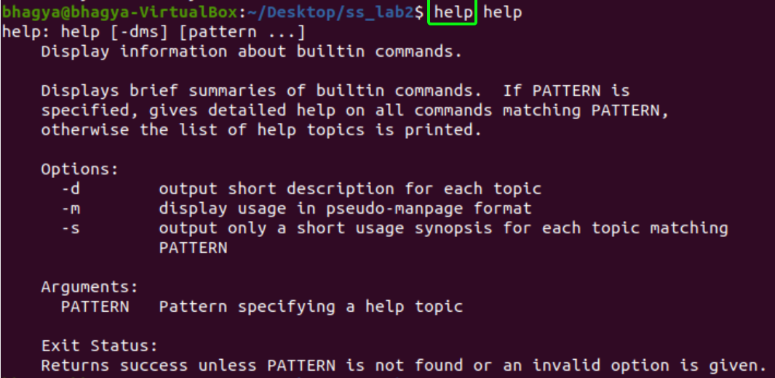

(d) **info** - reads documentation in the info format.

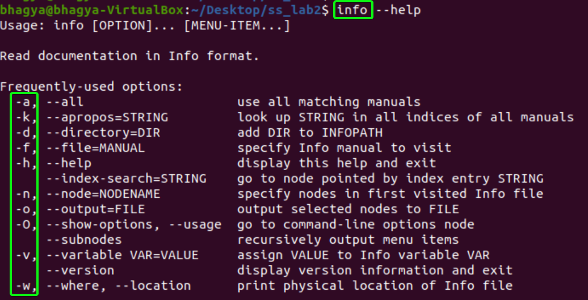

(e) **man** - to display the user manual of any command that we can run on the terminal.

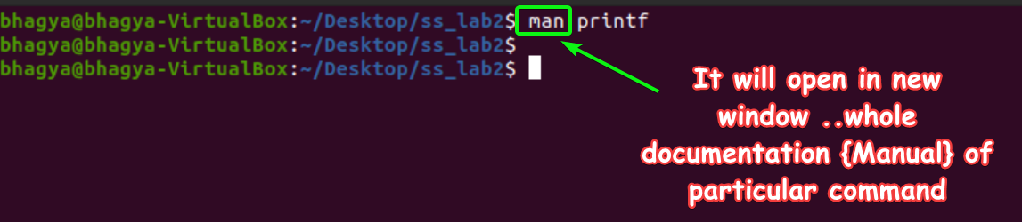

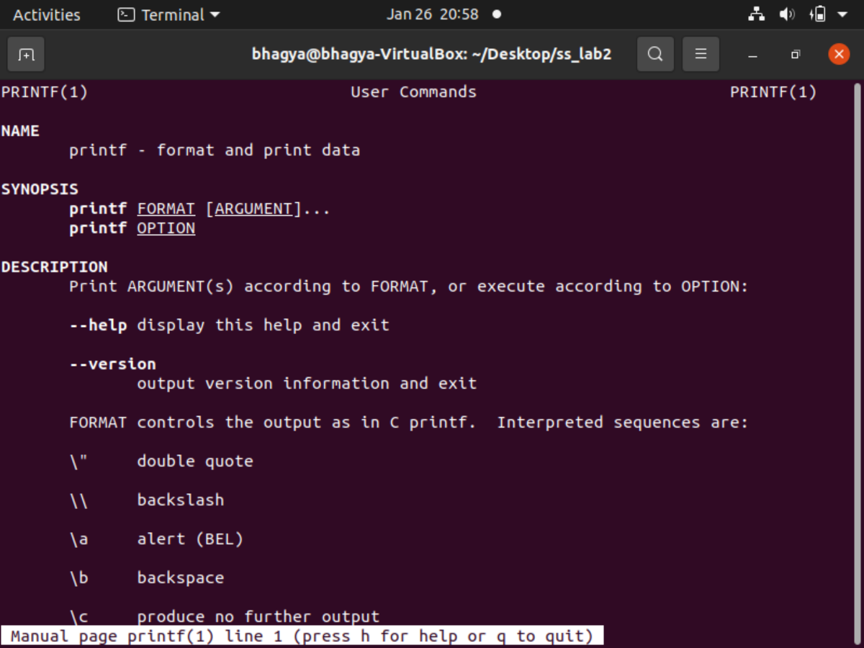

**help Vs info Vs man**

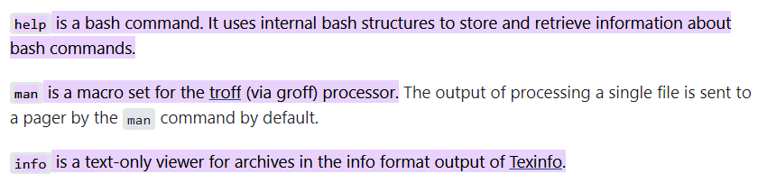

(f) **who** - is used to find out the following information :

* Time of last system boot
* Current run level of the system
* List of logged in users and more.



(g) **pwd** - short for *print working directory*, will help you to find out the absolute path of the current directory.



(h) **cat** (short for “**concatenate**“) - It reads data from the file and gives their content as output. It helps us to create, view, concatenate files.

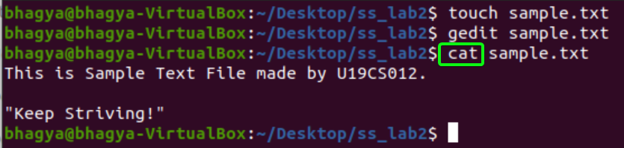

(i) **more** - used to view the text files in the command prompt, displaying one screen at a time in case the file is large.

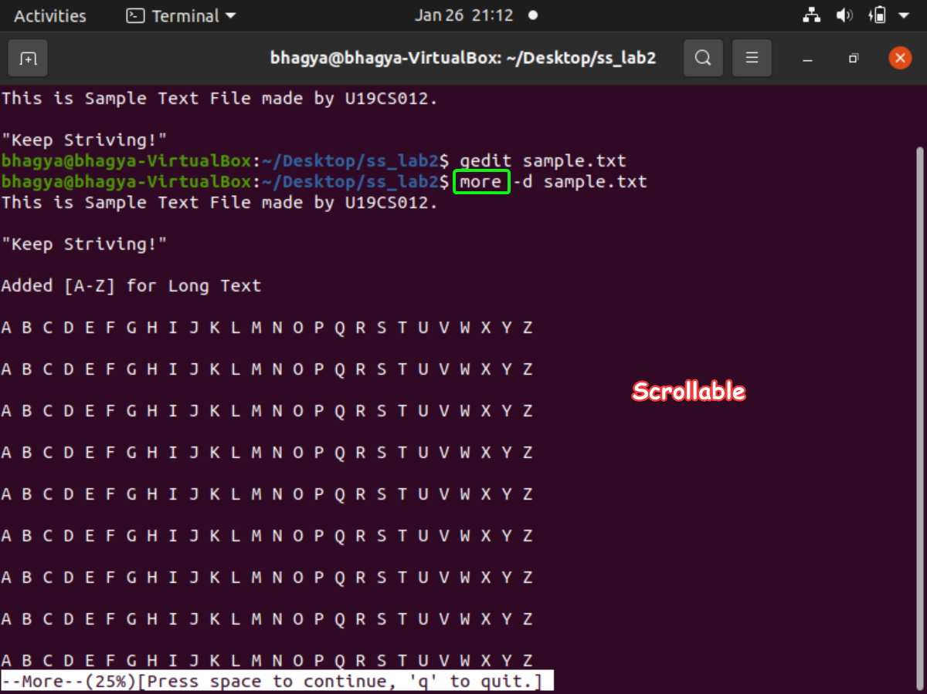

(j) **mv** - used to rename or move a file or directory



(k) **rm** - used to remove a file, or directory

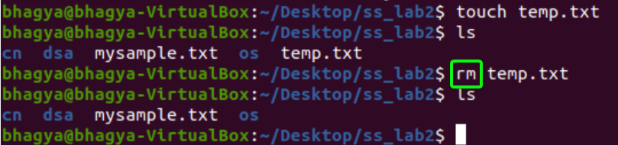

(l) **chmod** - change permissions of a file

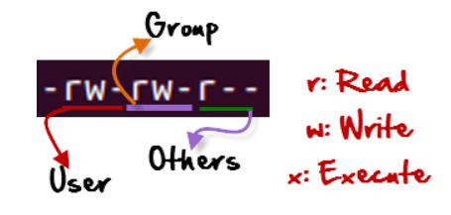

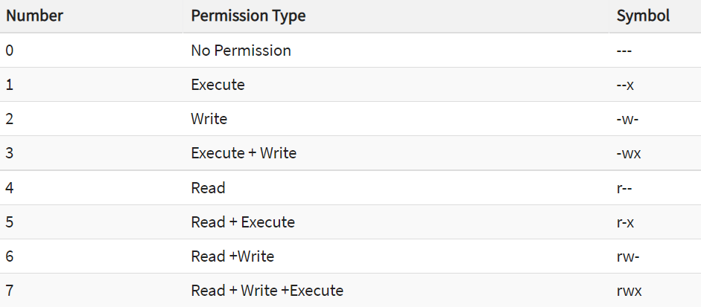

**Example**:

A.) Checking **Current File Permissions**



B.) **chmod 764** and Checking Permissions Again

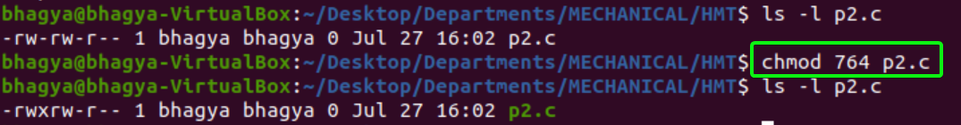

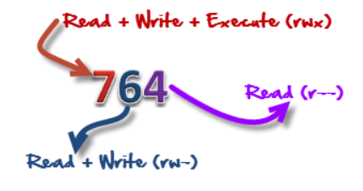

(m) **whoami** - will tell you which user account you are using in this system



(n) **logout** - to logout from current user session:

No output on screen, current user session will be logged out.

(o) **wc** - short for **word count**, help us to count newlines, words and bytes of a file.

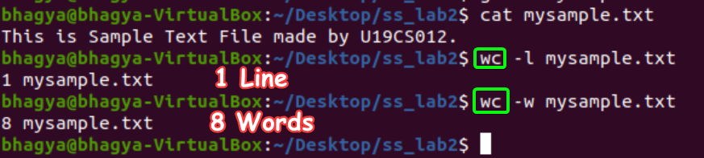

(p) **grep** - filter searches a file for a particular pattern of characters, and displays all lines that contain that pattern.

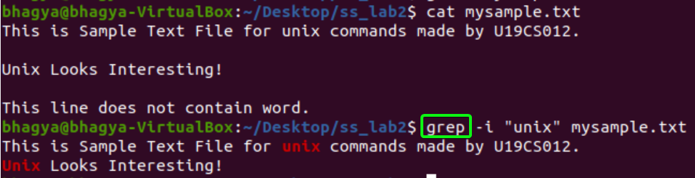

(q) **sort** - filter searches a file for a particular pattern of characters, and displays all lines that contain that pattern.

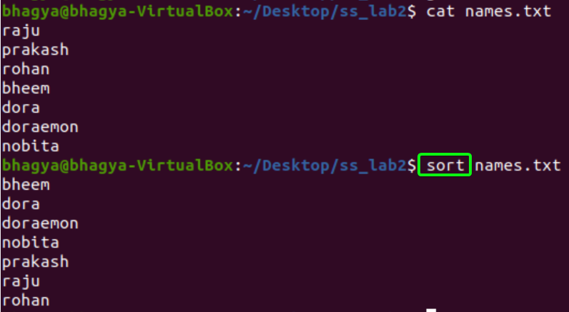

(r) **mkdir** - allows the user to create directories

(s) **rmdir** - allows the user to remove directories

(t) **cd** – (**change directory)** , used to change current working directory.

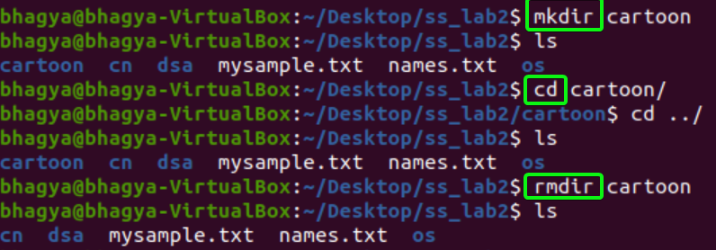

(u) **tail** - print the last N number of data of the given input.

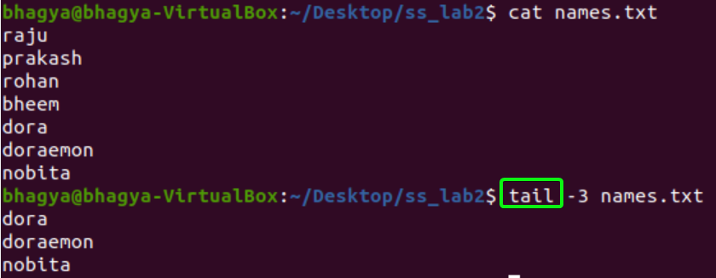

(v) **cmp** - used to compare the two files byte by byte and helps you to find out whether the two files are identical or not.

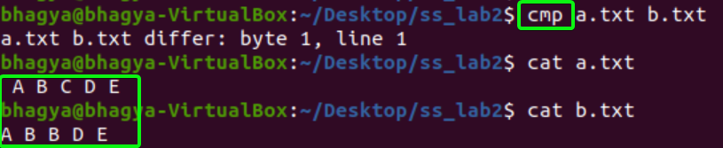

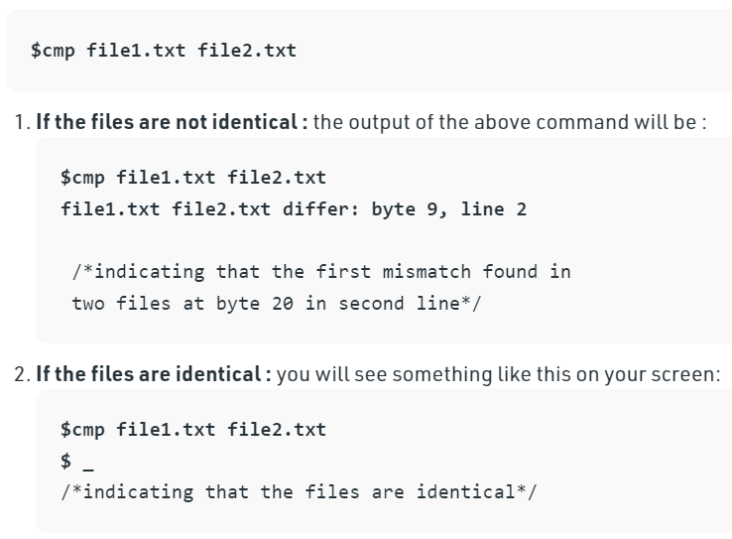

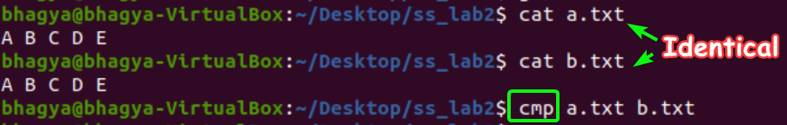

(w) **diff** - used to display the differences in the files by comparing the files line by line.

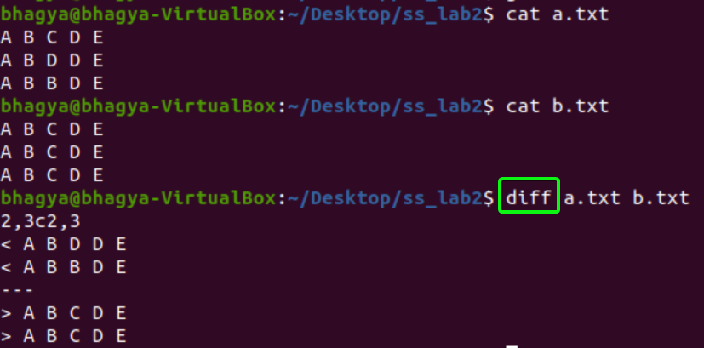

(x) **cp** (**copy**) - used to copy files or group of files or directory.

[*If the 2nd file doesn’t exist, then first it creates one and content is copied to it. But if it existed then it is simply overwritten without any warning.]*

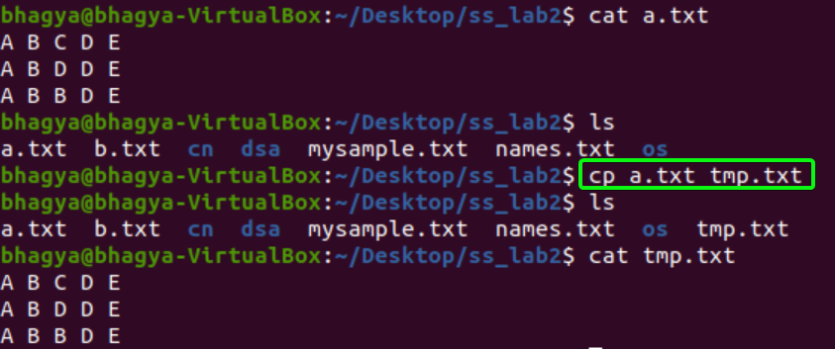

(y) **clear** – to clear the screen

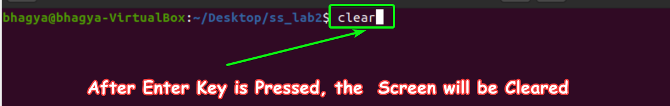

(z) **df** - (**disk free**), used to display info related to file systems about total space and available space.

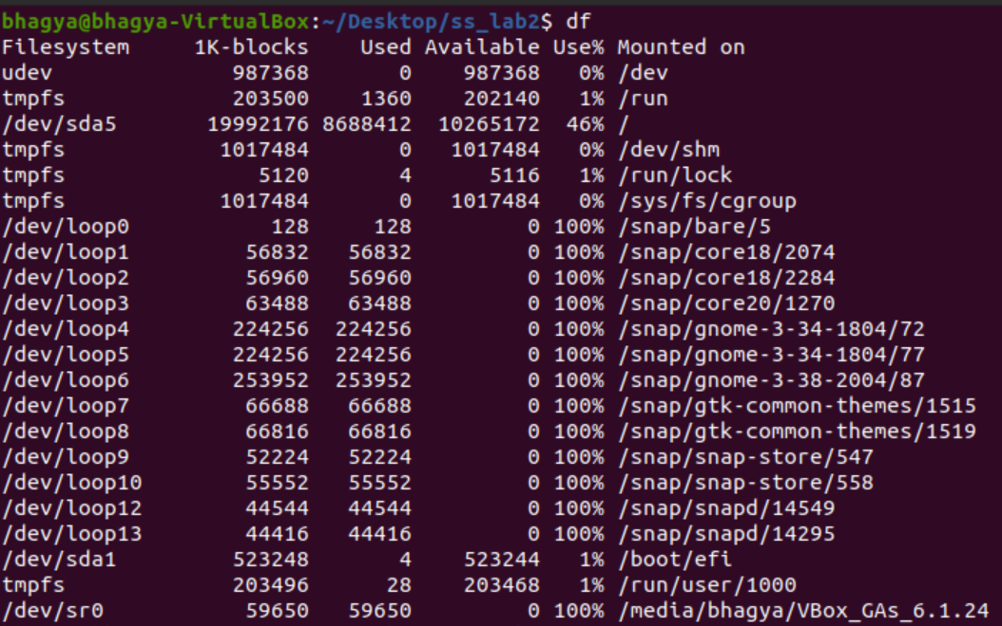

(1) **du** – (**disk usage**), is used to estimate file space usage.

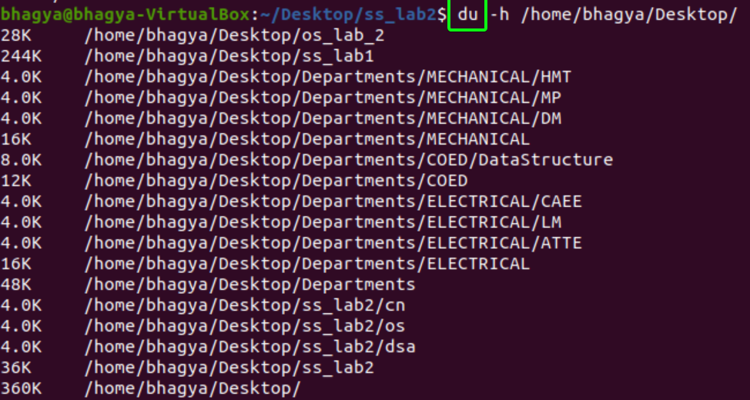

(2) **uname** - displays the information about the system.



(3) **apt-get** - command-line tool which helps in handling packages in Linux.

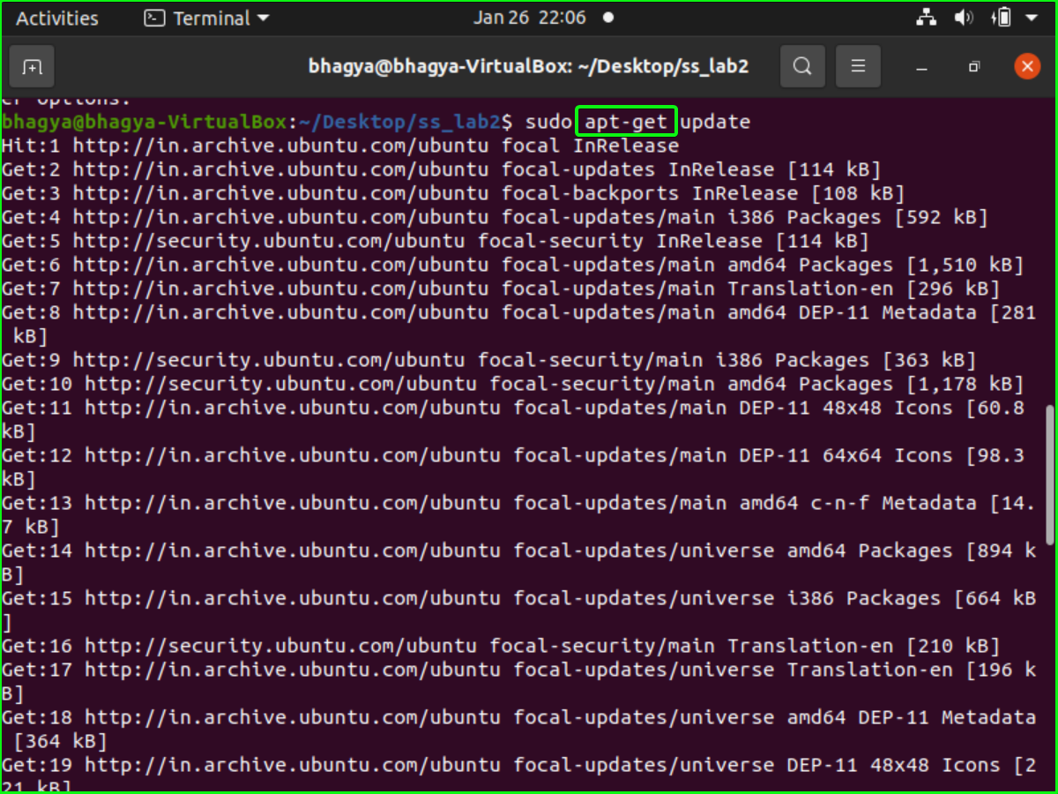

(4) **find** - command line utility for walking a file hierarchy. It can be used to find files and directories and perform subsequent operations on them.



(5) **wget** - non-interactive network downloader which is used to download files from the server even when the user has not logged on to the system and it can work in the background without hindering the current process.

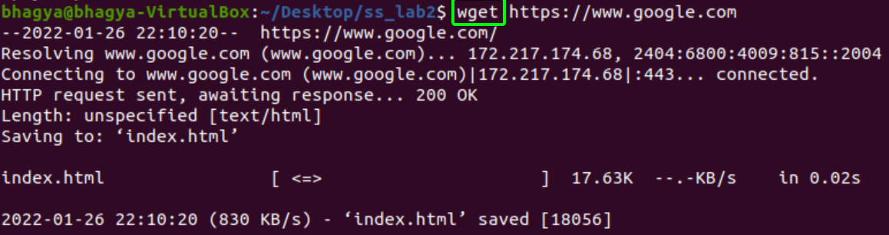

(6) **top** - used to show the Linux processes.

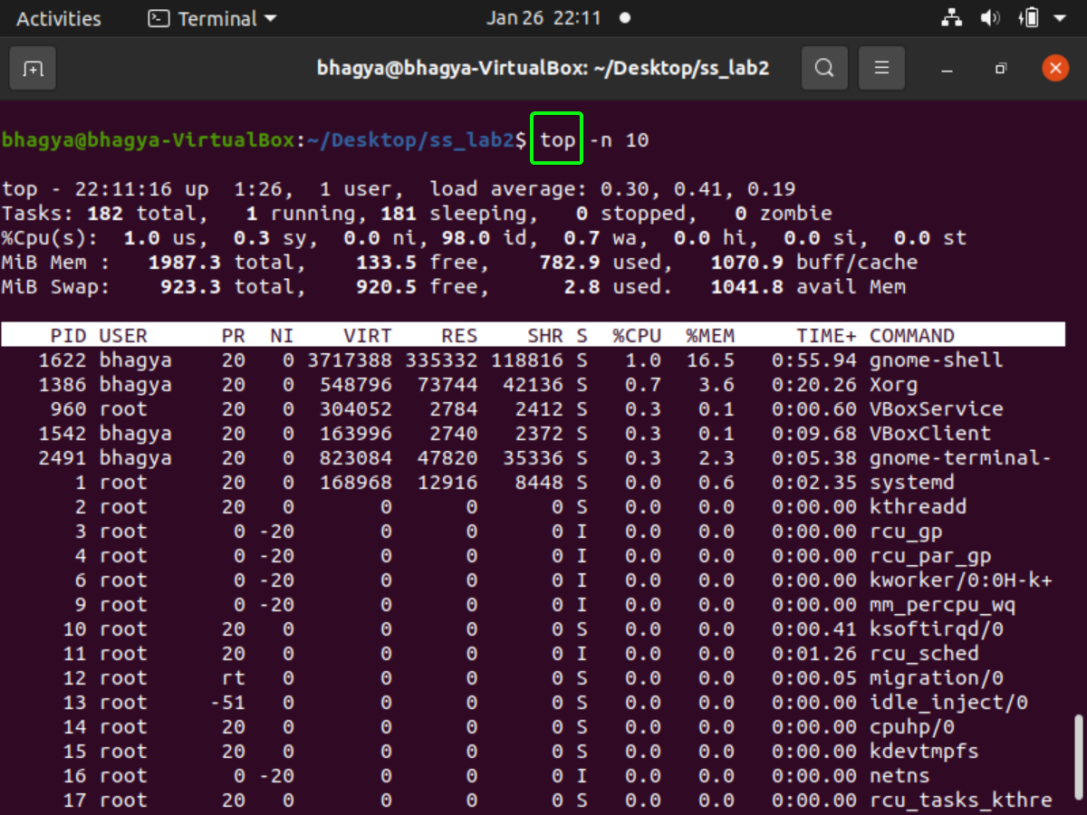

(7) **mpstate** - used to report processor related statistics.

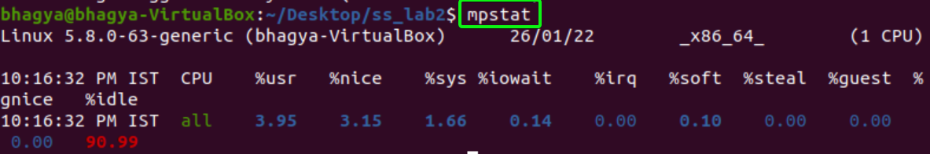

(8) **netstat** - displays various network related information such as network connections, routing tables, interface statistics, masquerade connections, multicast memberships etc.,

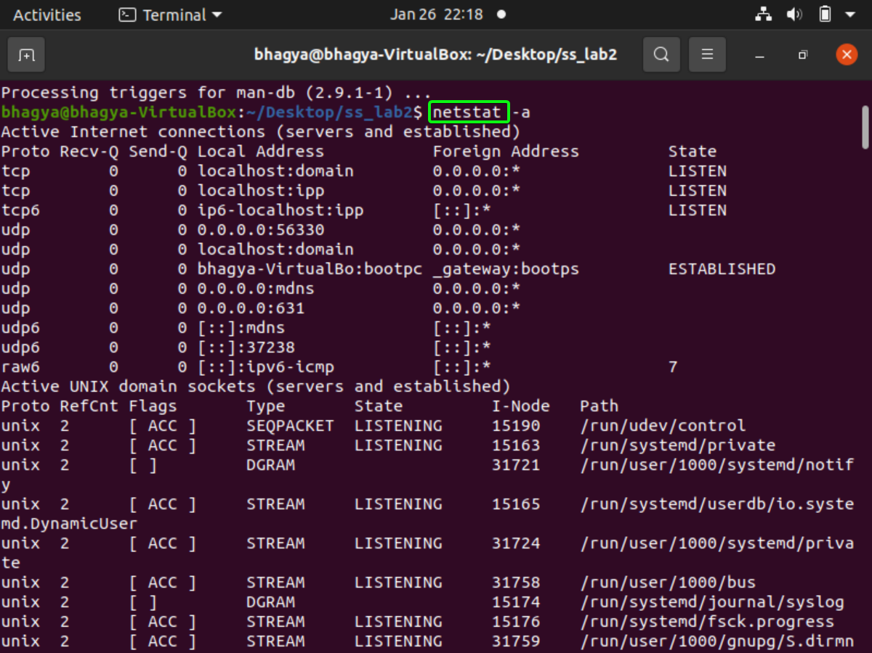

(9) **sar** [**System Activity Report**] - It can be used to monitor Linux system’s resources like CPU usage, Memory utilization, I/O devices consumption, Network monitoring, Disk usage, process and thread allocation, battery performance, Plug and play devices, Processor performance, file system and more.

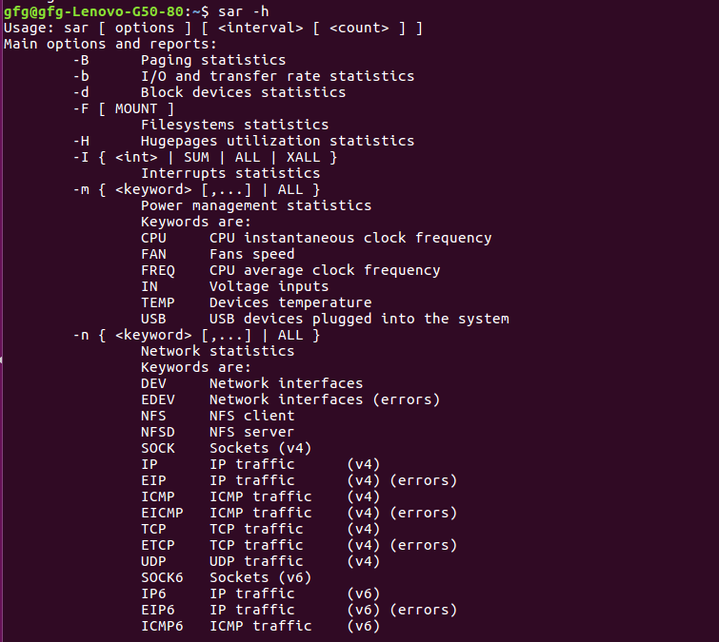

(10) **chown** - used to change the file Owner or group. Whenever you want to change ownership you can use chown command.

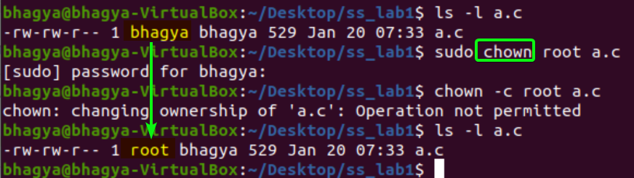

2. Linux commands related with process:

(a) **ps** (**Process Status**) - for viewing information related with the processes on a system

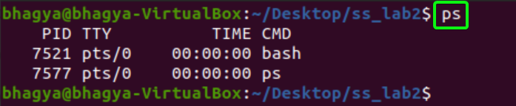

(b) **kill** - built-in command which is used to terminate processes manually.

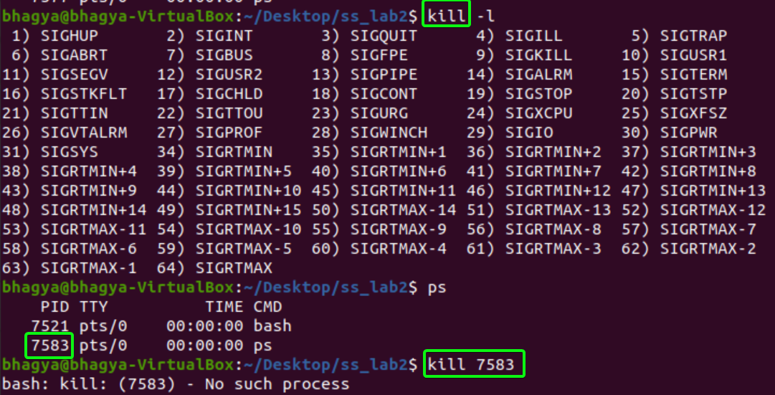

(c) **background processing (with &)** - To run a command in the background, add the ampersand symbol (&) at the end of the command.

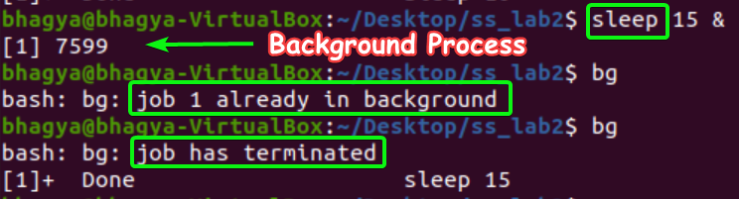

**SUBMITTED BY**: U19CS012

BHAGYA VINOD RANA